Environment, Empowerment & Employability of the Eves
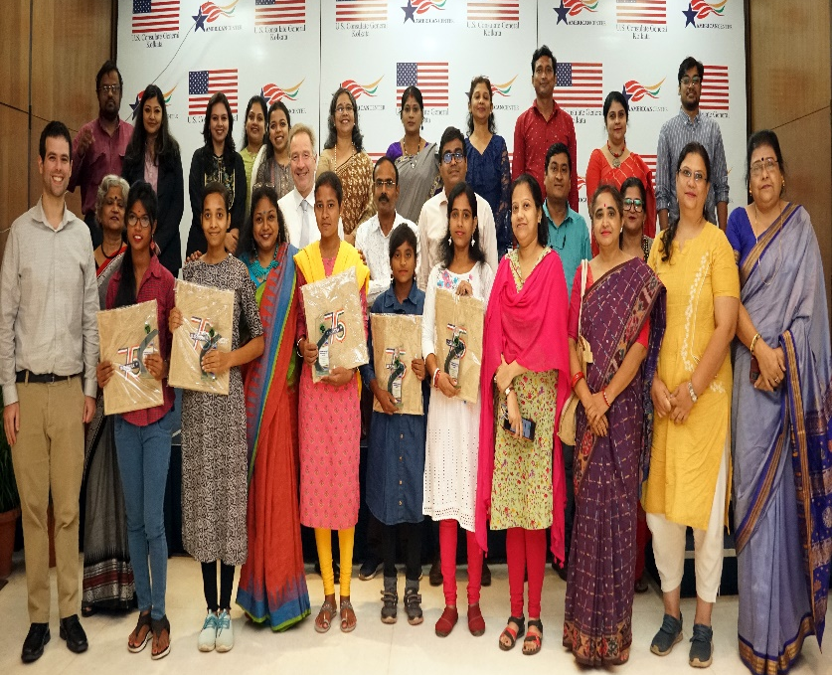
Capstone event of the US Embassy sponsored project which empowered 48 young tribal women from Purulia and Birbhum districts of West Bengal to engage in eco-friendly traditional livelihood, climate action moving towards gender empowerment.

The lifestyle and livelihoods practiced by tribal communities are traditionally and inherently environmentally responsible. However, the indigenous communities are not able to leverage their traditional wisdom either for climate action or for sustainable livelihood generation.This project aims to empower young tribal women to emphasize their traditional knowledge and contribute economically to both their families as well as their communities. Beneficiaries will receive first-hand experience at practical conservation alongside sustaining their traditional businesses.
The project empowered young students from colleges in two districts of West Bengal with high tribal population to attend the knowledge building workshops and participate in the group challenges which is part of the project activity. They will act as replicators among their communities and involve their households in the initiatives. The project will raise awareness and build capacity of the tribal women whose communities are already engaged in livelihoods that not only preserve but also nurture the environment, as an inherent part of their tradition. Such green jobs are poised at the intersection of a solution to benefit both ends of sustainable employability and climate action. According to ILO, green jobs are jobs that contribute to preserve or restore the environment, be they in traditional sectors such as manufacturing and construction, or in new, emerging green sectors such as renewable energy and energy efficiency. The program was action driven to train college going tribal girls to be able to sustain the green jobs in a professional manner and to contribute to climate action using their traditional conservation knowledge.
The two diverse locations vis-à-vis the target participants offered a degree of variance. The difference was observed in the specific ecosystems, as well as the overarching socio-ecological conditions (education, terrain, causal loops in the system, financial backgrounds, approach to life etc.).
Post graduate students at Purulia, while representing a large section of studentship from Santhal studies dept, were of varied intents and intellectual diversity, but mostly possessed of intention to work in the knowledge domain. Although most were first generation learners, there was a marked disconnect from their anthropological traditions as regards traditional eco-craft-based livelihoods even though they were sufficiently sensitized in their cultural memetics. Stories emerged that many from their high school cohort had dropped out and were engaged in such traditional eco-based crafts as their family livelihood.
In Birbhum skilled craftswomen from the Santhal tribal communities, most of them college or high school drop outs, married much below the legal age, were trained generationally in their traditional crafts. There was almost a universal lack of “business” skills, market linkages or network. Though their livelihood was aligned to environmental resilience (sourcing, designing of wares) practical ways of business sustainability was missing.

At the beginning, the students were completely disinterested and lacking in knowledge about their traditional craft. They were clear in their observations that in their specific ecology, livelihood was not linked to creating sustainably sourced tribal artifacts that could very well be a better fiscal opportunity. They anticipated teaching-learning/knowledge focused activities to be their only economically gainful future, especially in the long run. They seemed well-convinced that neither people in their villages nor relatives practiced any of these “arts” & “crafts” either as vocation or avocation, and such were “things of the past”. The live story and case-study shared with the students at the University had many of them ask, albeit informally, whether they could learn from the traditional artiste, whose story and wares were on display. The illustration that enthused interest by an iconic tribal lady, a sabai grass weaver of artefacts, who is presently exporting her products to the global North, had been trained by developmental sector experts.
The students who attended the Capstone at Kolkata were emphatic that they want to continue with their traditional knowledge and gain economically as well as contribute to climate action.

